**System Design Document**

**For**

**RF Direction Detection**

Cassandra Harrison

Robert Kramer

Sofia Mvokany

Krishna Patel

Kyle Reagan

|  |  |
| --- | --- |
| Version/Author | Date |
| 1.0/All | 9/29/2020 |
| 2.0/All | 10/29/2020 |
|  |  |
|  |  |

TABLE OF CONTENT

1. INTRODUCTION
   1. Purpose and Scope
   2. Project Executive Summary
      1. System Overview
      2. Design Constraints
      3. Future Contingencies
   3. Document Organization
   4. Project References
   5. Glossary
2. SYSTEM ARCHITECTURE
   1. System Hardware Architecture
   2. System Software Architecture
   3. Internal Communications Architecture
3. HUMAN-MACHINE INTERFACE
   1. Inputs
   2. Outputs
4. DETAILED DESIGN
   1. Hardware Detailed Design
   2. Software Detailed Design
   3. Internal Communications Detailed Design
5. EXTERNAL INTERFACES
   1. Interface Architecture
   2. Interface Detailed Design
6. SYSTEM INTEGRITY CONTROLS.

# **1** **INTRODUCTION**

## **1.1** **Purpose and Scope**

This document describes the system requirements, operating environment, system and subsystem architecture, files and database design, input formats, output layouts, human-machine interfaces, detailed design, processing logic, and external interfaces for the RF Direction of Arrival system. The scope of the project includes the receiving of 915MHz frequencies through a rotating loop antenna. The results will be displayed in real-time through a computer screen.

## **1.2** **Project Executive Summary**

### **1.2.1** **System Overview**

There are three sections to the system. One is the loop antenna, the RTL-SDR receivers, and the rotating platform. The loop antenna is a radio antenna consisting of a loop of copper wire and will be used as a receiving antenna at high frequencies. This loop antenna will be used for radio direction finding. RTL-SDR is software designed radio which is our computer-based radio scanner for receiving live radio signals within the area. The loop antenna will be connected to the rotating platform which will consist of the stepping motor. The stepping motor will rotate the loop antenna in the speed and direction we want.

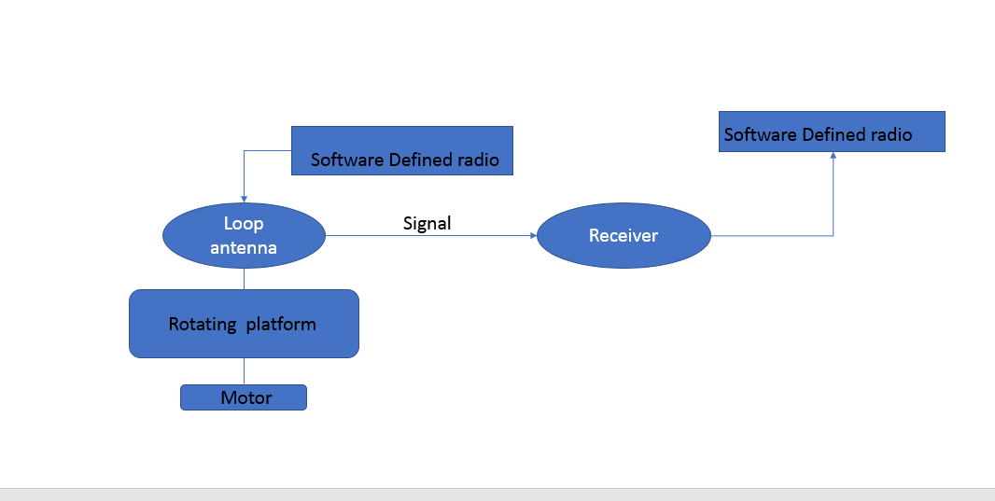

*Figure 1: High-level diagram of the system*

### **1.2.2** **Design Constraints**

The two design constraints are the pixhawk simulation drone that all testing will be done on as we do not have access to a drone to test it out in real-time and the budget constraint we had to keep all equipment ordered for the design under $1500.

### **1.2.3** **Future Contingencies**

There will be no contingencies applied to this system in the future.

## **1.3** **Document Organization**

This System Design Document details the system architecture in a high-level manner. It will briefly discuss the hardware and software system architecture. Along with the Human-Machine Interface where the inputs and outputs will be discussed. After that, there will be a detailed design section where it goes further into the hardware and software design aspects of the system. It will conclude with a short section discussing the integrity controls of the system.

## **1.4** **Project References**

The key references used in the creation and formation of the subsystem:

1. ARDUINO CNC SHIELD CONTROL STEPPER. [Online]. Available: <http://aconcaguasci.blogspot.com/2016/11/arduino-cnc-shield-control-stepper.html>. [Accessed: 21-Sept-2020 through 24-Nov-2020].
2. CNC ARDUINO SHIELD. [Online]. Available: <https://courses.ideate.cmu.edu/16-375/f2017/text/resrc/cnc-shield.html#nema17-stepper-motor>. [Accessed: 28-Oct-2020 through 24-Nov-2020].
3. LECTURE 11: LOOP ANTENNAS. [PDF]. Available: <http://www2.elo.utfsm.cl/~elo352/biblio/antenas/Lectura%2011.pdf>. [Accessed: 11-Sept-2020 through 24-Nov-2020].
4. HANDHELD DIRECTION FINDING LOOP ANTENNA FOR RFI LOCATION. [PDF]. Available: <http://www2.elo.utfsm.cl/~elo352/biblio/antenas/Lectura%2011.pdf>. [Accessed: 11-Sept-2020 through 24-Nov-2020].

## **1.5** **Glossary**

DOA- Direction of Arrival

RF- Radio Frequency

SDD - Software Design Document

UDP - User Datagram Protocol

# **2** **SYSTEM ARCHITECTURE**

## **2.1** **System Hardware Architecture**

The system hardware architecture is described in Figure 1 previously mentioned in the System Overview section of the SDD. In this section will go in depth of what each subsystem will do.

* Motor: The stepping motor which is wired to a CNC shield and connected to an Arduino Uno board.
* Rotating platform: The rod attached to the stepping motor, where the loop antenna will attach to.
* Loop Antenna: A coiled copper wire, the purpose will be to receive radio frequencies.
* Software Defined Radio: Helps detect the radio frequencies within the area and make it visible on the computer.
* Receiver: Helps loop antenna receive signals.

## **2.2** **System Software Architecture**

**2.2.1** **Rotating Platform**

The rotating platform allows the loop antenna attached to it to rotate at the speed and directions set by the user. The simple code to run the stepper motor is explained in the diagram below. Note that this is not a traditional class diagram as used in software development, since the code is so simple.

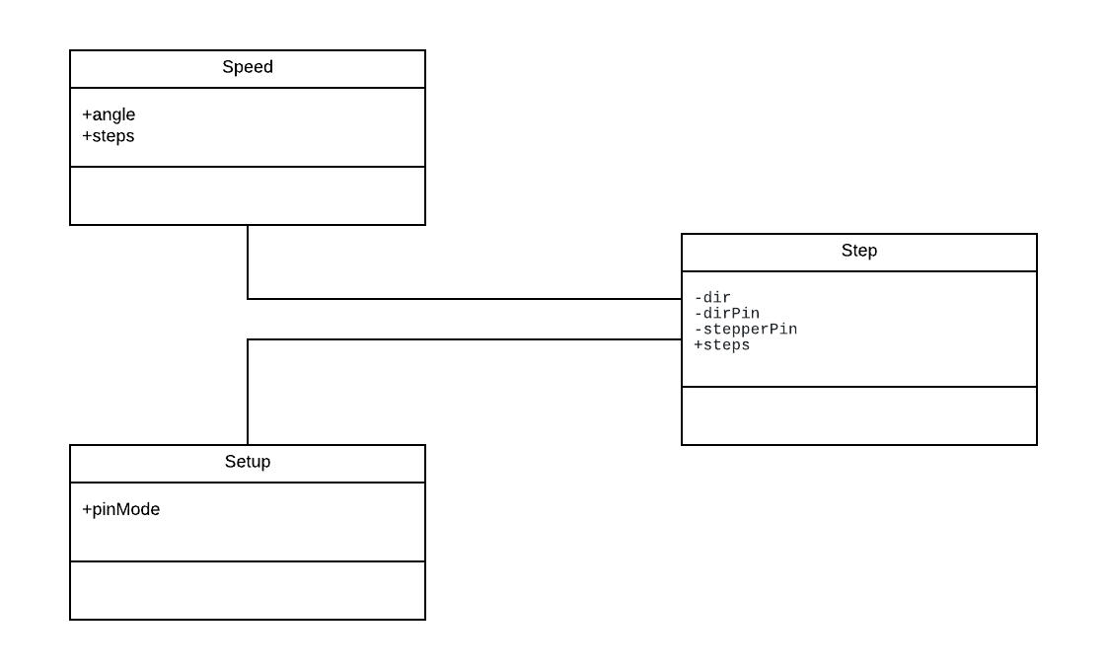

*Figure 2: Class diagram of the rotating platform*

Speed: Controls the speed of the rod attached to the stepping motor and returns the angle at which it is currently at.

Setup: Assigns the X,Y,Z directions to the corresponding pins on the CNC and Arduino Uno boards.

Step: Main function that outputs the angle on the serial port and transmits the speed and direction to the stepping motor.

## **2.3** **Internal Communications Architecture**

The data flow diagram below represents the internal communications of the system. The loop antenna attached to the rotating platform will turn in the speed and direction coded in by the user. As the loop antenna rotates, the RTL-SDR will assist the loop antenna scan for frequencies around 915Mhz which the user will be able to see through their PC. Once the frequency has been caught the rotating platform will stop rotating so we can continue reading the signal that was scanned.

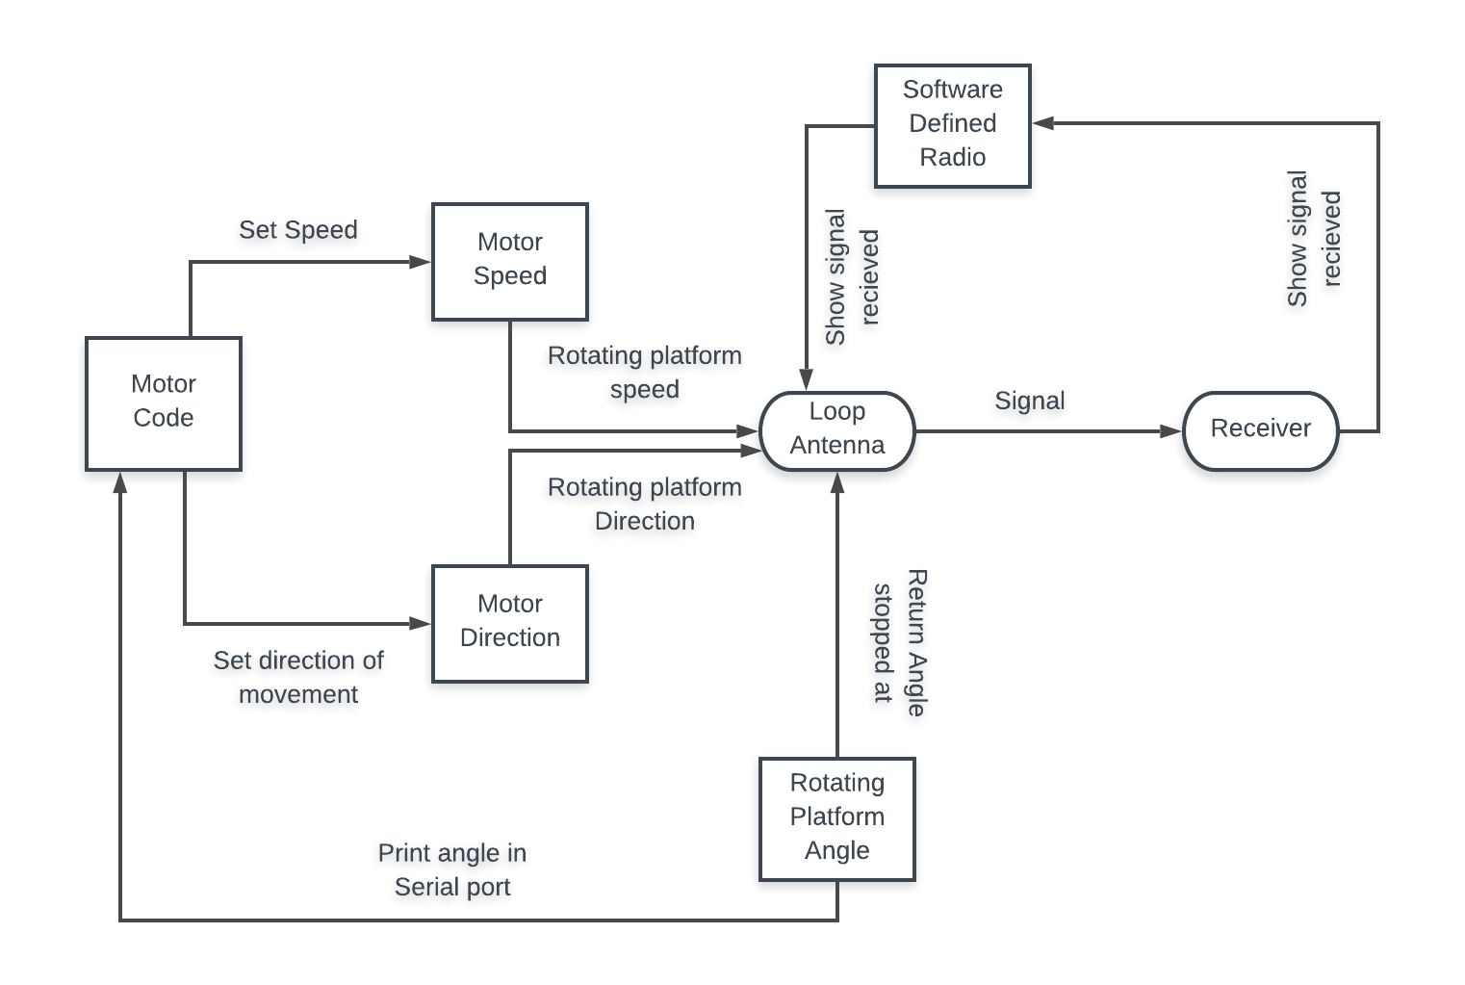

*Figure 3: Data flow diagram of the process of RF direction detection*

# **3** **HUMAN-MACHINE INTERFACE**

This section provides details of the inputs and outputs to verify the system’s ability to accurately detect 915MHz frequencies in the nearby area, within a controlled simulation.

**\*\*\*\*\*\*\*\*\*\*\*\*\*\*\*\*\*\*\*\***

**Just received the pixhawk to be able to run a simulated scenario will update these sections when testing has been done in Sprint 4.**

**\*\*\*\*\*\*\*\*\*\*\*\*\*\*\*\*\*\*\*\***

## **3.1** **Inputs**

This section is a description of the input media used by the operator for providing information to the system; show a mapping to the high-level data flows described in Section 1 .2.1, System Overview. For example, data entry screens, optical character readers, bar scanners, etc. If appropriate, the input record types, file structures, and database structures provided in Section 3, File and Database Design, may be referenced. Include data element definitions, or refer to the data dictionary.

Provide the layout of all input data screens or graphical user interfaces (GUTs) (for example, windows). Provide a graphic representation of each interface. Define all data elements associated with each screen or GUI, or reference the data dictionary.

This section should contain edit criteria for the data elements, including specific values, range of values, mandatory/optional, alphanumeric values, and length. Also address data entry controls to prevent edit bypassing.

Discuss the miscellaneous messages associated with operator inputs, including the following:

* Copies of form(s) if the input data are keyed or scanned for data entry from printed forms
* Description of any access restrictions or security considerations
* Each transaction name, code, and definition, if the system is a transaction-based processing system

## **3.2** **Outputs**

This section describes the system output design relative to the user/operator; show a mapping to the high-level data flows described in Section 1.2.1. System outputs include reports, data display screens and GUIs, query results, etc. The output files are described in Section 3 and may be referenced in this section. The following should be provided, if appropriate:

* Identification of codes and names for reports and data display screens
* Description of report and screen contents (provide a graphic representation of each layout and define all data elements associated with the layout or reference the data dictionary)
* Description of the purpose of the output, including identification of the primary users
* Report distribution requirements, if any (include frequency for periodic reports)
* Description of any access restrictions or security considerations

# **4** **DETAILED DESIGN**

This section provides the information needed for a system development team to actually build and integrate the hardware components, code and integrate the software modules, and interconnect the hardware and software segments into a functional product. Additionally, this section addresses the detailed procedures for combining separate COTS packages into a single system. Every detailed requirement should map back to the FRD, and the mapping should be presented in an update to the RTM and include the RTM as an appendix to this design document.

## **4.1** **Hardware Detailed Design**

A hardware component is the lowest level of design granularity in the system. Depending on the design requirements, there may be one or more components per system. This section should provide enough detailed information about individual component requirements to correctly build and/or procure all the hardware for the system (or integrate COTS items).

If there are many components or if the component documentation is extensive, place it in an appendix or reference a separate document. Add additional diagrams and information, if necessary, to describe each component and its functions, adequately. Industry-standard component specification practices should be followed. For COTS procurements, if a specific vendor has been identified, include appropriate item names. Include the following information in the detailed component designs (as applicable):

* Power input requirements for each component
* Signal impedances and logic states
* Connector specifications (serial/parallel, 11-pin, male/female, etc.)
* Memory and/or storage space requirements
* Processor requirements (speed and functionality)
* Graphical representation depicting the number of hardware items (for example, monitors, printers, servers, I/O devices), and the relative positioning of the components to each other
* Cable type(s) and length(s)
* User interfaces (buttons, toggle switches, etc.)
* Hard drive/floppy drive/CD-ROM requirements
* Monitor resolution

**4.1.1** **Rotating Platform**

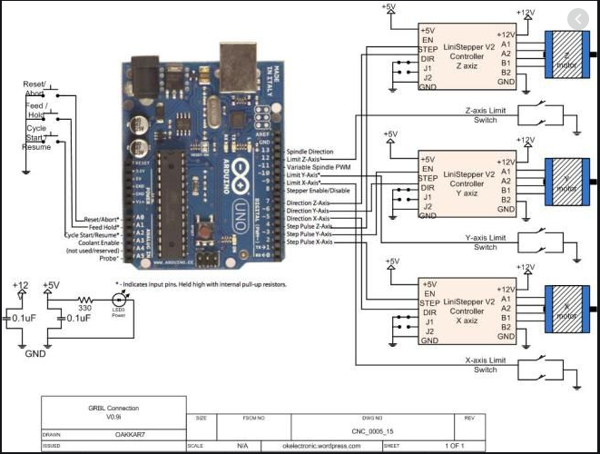

*Figure 4: Pin mapping and wiring of the Rotating Platform*

**4.1.2** **Loop Antenna**

* S-LMR240
* Coax cable

**4.1.3** **RTL-SDR**

* <1 PPM temperature compensated oscillator
* SMA female antenna port
* 4.5 V USB powered bias tee
* HF Direct Sampling Mode: Built in 25 MHz low pass filter
* Aluminum case and passive cooling

## **4.2** **Software Detailed Design**

This section is not applicable as there is no major software component of the system. The Rotating platform basic software to control speed and directions and printing the angle of loop has been described in the System Software Architecture section of the SDD.

## **4.3** **Internal Communications Detailed Design**

If the system includes more than one component there may be a requirement for internal communications to exchange information, provide commands, or support input/output functions. This section should provide enough detailed information about the communication requirements to correctly build and/or procure the communications components for the system. Include the following information in the detailed designs (as appropriate):

* The number of servers and clients to be included on each area network
* Specifications for bus timing requirements and bus control
* Format(s) for data being exchanged between components
* Graphical representation of the connectivity between components, showing the direction of data flow (if applicable), and approximate distances between components; information should provide enough detail to support the procurement of hardware to complete the installation at a given location
* LAN topology

******

Will include diagrams of the final product once assembled and include detailed description of data flow. Currently have separate components working that need to be assembled together.

******

# **5** **EXTERNAL INTERFACES**

The other system that works alongside the RF Directions Detection system will be any drone within the area. There is no system that needs to work simultaneously with the RF system. The RF Direction Detection system is scanning for drones within the area if it does not find one then there are no drones in the area.

## **5.1** **Interface Architecture**

The communication between the drone in question is described in the Human-Machine Interfaces Input section of the SDD. The frequency the drone runs on will be scanned by the loop antenna and the software defined radio. Once detected by the system the Rotating Platform will stop so the loop antenna and software design radio and continue receiving the signal of the drone and find it’s location.

## **5.2** **Interface Detailed Design**

For each system that provides information exchange with the system under development, there is a requirement for rules governing the interface. This section should provide enough detailed information about the interface requirements to correctly format, transmit, and/or receive data across the interface. Include the following information in the detailed design for each interface (as appropriate):

* The data format requirements; if there is a need to reformat data before they are transmitted or after incoming data is received, tools and/or methods for the reformat process should be defined
* Specifications for hand-shaking protocols between the two systems; include the content and format of the information to be included in the hand-shake messages, the timing for exchanging these messages, and the steps to be taken when errors are identified
* Format(s) for error reports exchanged between the systems; should address the disposition of error reports; for example, retained in a file, sent to a printer, flag/alarm sent to the operator, etc.
* Graphical representation of the connectivity between systems, showing the direction of data flow
* Query and response descriptions

If a formal Interface Control Document (ICD) exists for a given interface, the information can be copied, or the ICD can be referenced in this section.

See diagrams in Human-Machine Interfaces Input and Output.

# **6** **SYSTEM INTEGRITY CONTROLS**

There is no sensitive information to the software or hardware of the system. The system is created for an IEEE competition and will be available to students of the Embry Riddle Campus to demonstrate RF Direction Detection. The general public will be provided with the information and design of the system.